PROGRAM IMPLEMENTATION REPORT

The Roma Versitas Kosovo Program is implemented by Advancing Together and it is funded by Roma Education Fund (REF).
September 2016
The main project objective: To increase the retention rate, academic performances and graduation rate, while build the self-esteem and identity of about 80 Roma students enrolled in tertiary education in Kosovo, while improving their professional and personal skills to contribute to its communities and Kosovo Society in general.

The key Project Development Objective Outcome Indicators:

- At least 80 Roma students are to receive tutoring assistance and they Increase GPA of against individual baseline result;
- at least 80 % of them are expected to successfully pass the exam(s) in which they received tutoring;
- At least 20 Roma high school graduates/freshmen students are expected to receive non-formal peer mentoring for supporting their university education;
- A total of 80 students are expected to participate in 7 thematic academic workshops/training (60 Roma and 20 non-Roma students);
- A total of 50 Roma students attend foreign language and 25 students’ computer courses;
- 6 SIPs are designed and implemented by the project beneficiaries;
At least 5 interns are trained and engaged in community development initiatives.
The main PO is considered as fully met as per the implemented activities.
The key Project Development Objective Outcome Indicators:
- At least 80 Roma, Ashkali and Egyptian university students are expected to benefit from the RV assistance offered.

RV Kosovo Program in total has 80 student beneficiaries from different field of studies (Medicine, Economy, Law, Political Science, Public Safety, Architecture, Electro Technics, Arts, Education and Management).

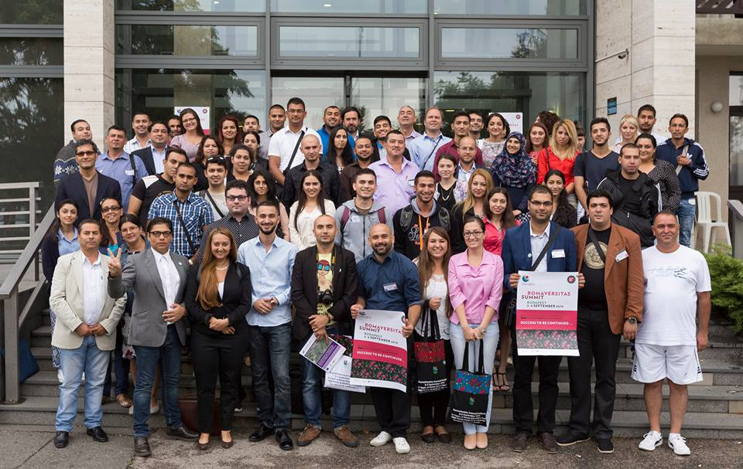

Due to budgetary sealing (limitations in numbers of beneficiaries) and with aim to offer to as many as possible students access to the program, after the consultation with its Advisory Board, RV Kosovo Program has developed waiting list with potential candidates. With the grade transcripts of RV students, 88% of students have successfully passed their respective exams. Two students finished their studies successfully, one student has finished Law in the University of Peja and she became graduated in Law Science, another student has finished Faculty of Security Studies in the ISPE College and he earned bachelor degree in economic studies.

- At least 20 Roma high school graduates/freshmen students are expected to receive non-formal peer mentoring for supporting their university education;

RV Kosovo Program identified 6 mentors from under graduate students the aim to support freshmen students and inform them for students life, during this period mentors were mentoring a total of 16 freshmen students.
During the reporting period, all above-mentioned freshmen students received the necessary support from their respective mentors in accordance to the outlined Mentors’ Terms of Reference. For the academic year 2015/2016 the number of freshmen students registered in the RV program will increase in coming academic year 2016/2017.
- A total of 80 students are expected to participate in 6 thematic academic workshops/training (60 Roma and 20 non-Roma students);

RV Kosovo Program has developed following academic workshops:

- Academic Writing;
- Time Management;
- CV writing and interview skills;
- Presentation and communication skills;,
- Project Proposal Writing; and
- Project Cycle Management.

From the above workshops, a total of 81 students benefited from these academic trainings.
- A total of 50 Roma students attend foreign language;

Inter-institutional Cooperation

AT RV has continued with its activities of developing stakeholder network of the RV Kosovo project and managed to arrange meetings with other organizations who might potentially support students in the country and region and promoting Roma Versitas around Kosovo.
During the reporting period AT managed to have a meeting with Mr. Haki Abazi Director of Rockefeller Brothers Fund (RBF) for Balkan’s, RBF Fund is one of potential donors of RV Kosovo program. The meeting had a fundraising character in view of exchange of ideas for supporting of RV program students. AT will follow-up accordingly on this matter as it was agreed to prepare a concept note during the year.

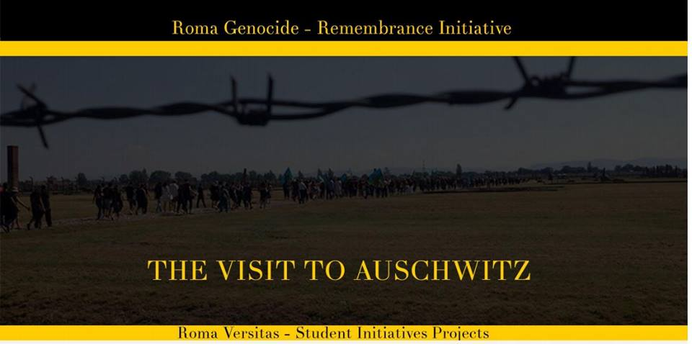

During the reporting period AT RV in cooperation with Innovation Lab Kosovo - ILK (UNICEF founded program) has organized meeting with Ms. Nita Zeqiri with aim to organize two day training one day Project Proposal Writing and one day Project Cycle Management for RV beneficiary students. During the meeting we have agreed that ILK will provide free of charge trainers for RV and AT will provide space, food, refreshments and other training materials for training.
With the aim of developing of partner network, RV Program Manager met with Mr. Diedon Kica, potential trainer for Time Management, Project Proposal writing, Project Cycle Management, Interview and CV writing with aim to develop the above program and its related agenda.

With aim to complete ADB members, RV has organized meeting with new director of office for community affairs in the Ministry of Education Science and Technology, Mr. Vedat Bajrami, with Mr. Bajrami we have agreed to announce him as AB member for RV program, and replace Ms. Enesa Kadic.

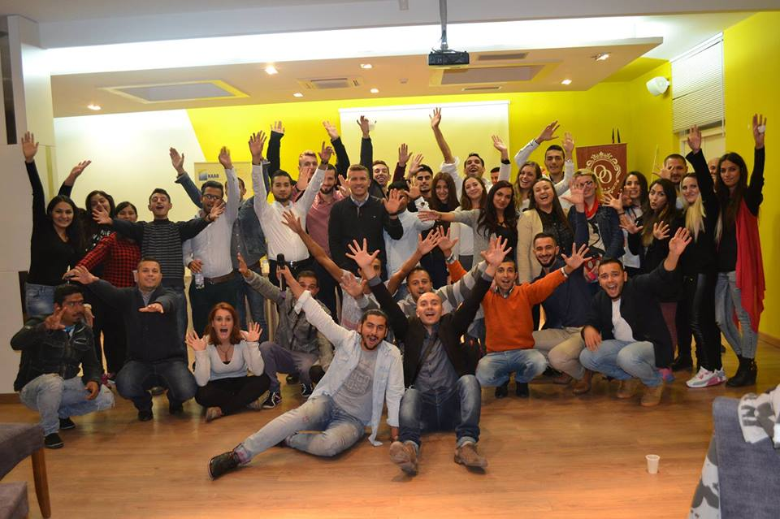

During the reporting period RV Kosovo has visited RV Albania with aim to develop RV network in the region. In this meeting RV Kosovo and RV Albania agreed to organize first joint cross-border training in the field of Academic Writing. In this regard, it was widely agreed to enable human and social communication between students. First of such a cross-border activity shall be held in Prizren during the period of May 2016.

Advisory Board (AB)

Even if attempted to hold the AB meeting, for unforeseen reasons, due to changes that have taken place in the Ministry of Education, Science and Technology (MEST), Mr. Vedat Bajrami was replaced by another MEST staff member. In addition, due to the changes that took place, namely the transformation from KAAD to AT; AB membership was informed only via email for the changes in the organization and RV program. The AB meeting is planned to be held at the end of May 2016. The AB has one member les until MEST will decide who will replace Enesa Kadic.
On 13th of July 2016 AB members meeting took place in AT HQ-Prishtina in order to discuss activities developed from Roma Versitas Program, AT reported on all project implemented activities for period January – June 2016, and also presented its plans which are to be implemented in future July-December 2016. Next meeting were planned to be organized in November 2016.
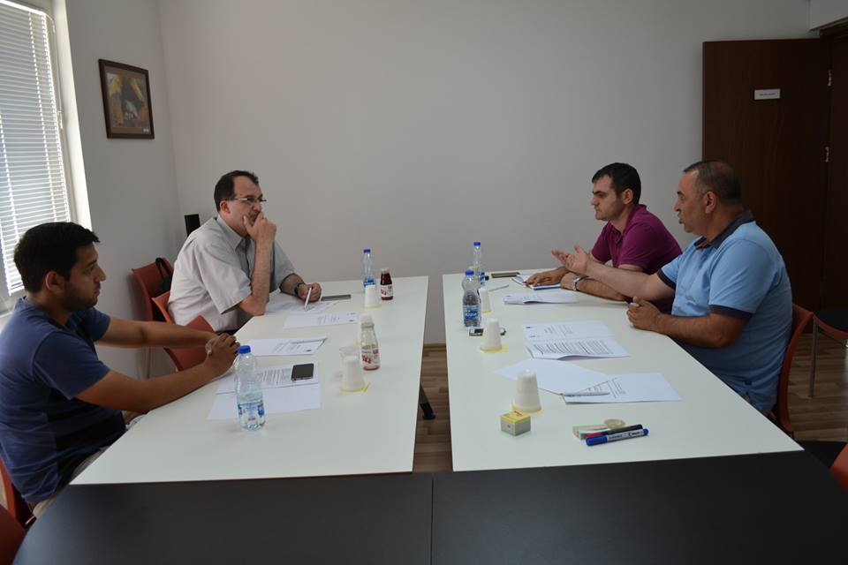

Due to changes in the MEST, RV Program Manager has appointed meeting with new director of office for community affairs in the Ministry of Education Science and Technology, Ms. Nazan Safqi. The aim of the meeting was appointing a new RV board member in order to replace Ms. Enesa Kadic.

Recourse Center and Library

During the reporting period, AT RV has produced the list with books requested from students and provided its library with 4 titles of books for the fields of Arts and Music, Academic Writing and Medicine as per student’s needs.
In cooperation with Tutors, Mentors and students, AT RV developed the list with books needed for Medicine, Law, Economy, Education and Computer Science for entire study cycle and for the coming period is planning to purchase those books.
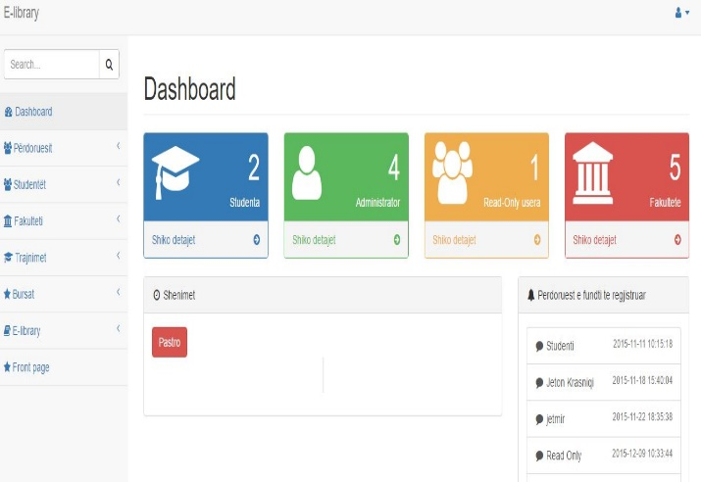

Now RV library counts: 374 hard copies of books, over 350 electronic titles of books in the different fields of studies. Furthermore, students are using library regularly not only to borrow books with themselves also they use library space for studying.
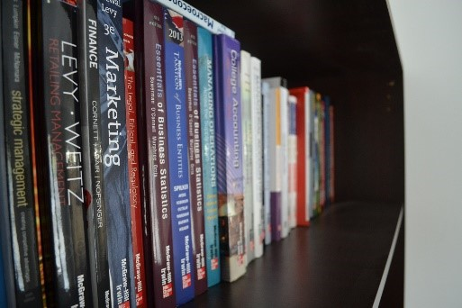
During this period, 36 students used the library books purchasing 19 titles in accordance to the library procedures.
RV Center in Prizren and Peja are fully equipped and operating functionally in the benefit of the students.

http://elibrary.advancing-together.org//home/index

Organizing Academic Tutoring Scheme

Based on the needs assessment carried out individually with students through fulfilling of “Application form for tutorship academic support”, RV gathered information from the students in order to organize tutorship activities as per PIMP. RV agreed with tutors to organize tutorship sessions and payment to be done in May 2016 after RV receives grant from REF. During the reporting period, RV identified the need for tutorship for RV students in the related field of studies as per the bellow table:

Table of lessons requested from students by field of studies and the specific subject (Jan-April 2016)
Field of studies | Subject name | Subject name | Subject name | Subject name | Subject name | Subject name | Subject name
Medicine | Anesthesiology in Surgery | Physiotherapy in Chirurgic | Pathology | Kinesiology II | Kinesiology | pediatric | Medical Ethics
Medicine | Statistics | Statistics Prosthetics | Anatomy | Gynecology | Internee Medicine | Medical Care
Economy | Managerial Accounting | Service Management
Law | Institutional Law | Jurispondence | Human Rights
Education | Academic Writing | Mathematics
Computer Science | Cryptography
Political Science | Academic Writing | Mathematics
Agriculture | Chemistry

Table of lessons requested from students by field of studies and the specific subject (May-July 2016).
Field of studies | Subject name | Subject name | Subject name | Subject name | Subject name | Subject name | Subject name
Medicine | Statistics | Medical Ethics | Surgery | pediatric | Epidemiology
Economy | Accounting | Mathematics | German Language | English Language
Law | Contracts | Jurispondence | Human Rights | Methodology of Law writing | Hunan Rights and Security Sector
Education | Phycology | Mathematics | Philosophy | Albanian Language I
Computer Science | German Language
Agriculture | Botanic

Tutor selection

RV is continuously is recruiting new tutors as per students’ needs identified from monthly plans prepared from students with support of their assigned mentors.
During the reporting period, RV selected tutors for the lessons in the field of Economy, Computer Science, and Anatomy. As per monthly plan, we identified need for new tutors in the field of Medicine, Economy and Electro Technics where we have contacted several potential candidates from our database and also we have taken in to consideration referrals from students and tutors. For this period we have engaged 6 new tutors in the fields of Anatomy, Education, Electro Technics, German Language and Economy.

Provision of Tutorship Services

During the reporting period, 25 tutors were involved in the tutorship from different fields, 9 tutors from Medicine, 4 tutor from Law, 5 tutor from Education, 5 tutor from Economy, 1 tutor from Computer Science, and 1 tutor from Agriculture.
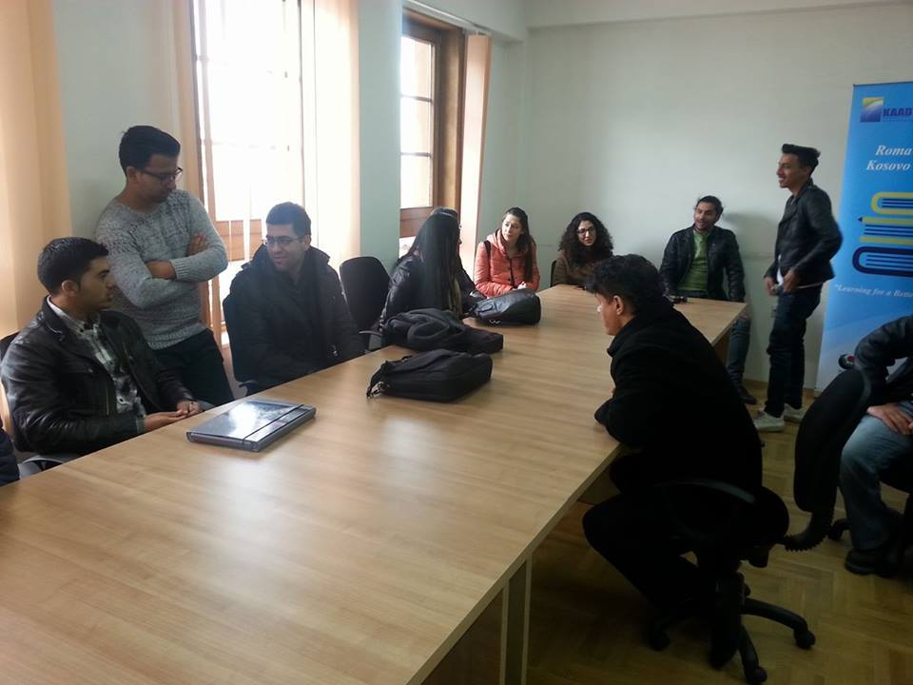
In total, during the reporting period (January-July 2016) a total of 771 hours were delivered to a total of 60 student as follows:
- Medicine 383 hours/ 25 students;
- Law 58 hours /8 students;
- Education 107 hours/ 11 students;
- Economy 133 hours/ 10 student;
- Computer Science 26 hours /4 student;
- Political Science 15 hours/1 student;
- Agriculture 49 hours/2 student;

Table of the students attended lessons by field of the studies and gender
Students by Gender | Economy | Medicine | Law | Education | Computer Science & Electro | Agriculture | Total
Male | 4 | 14 | 5 | 2 | 4 | 2 | 31
Female | 6 | 11 | 3 | 9 | 0 | 0 | 29
 | 10 | 25 | 8 | 11 | 4 | 2 | 60

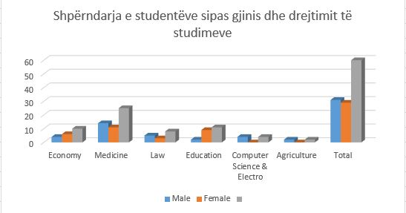

After having tutorship sessions, RV staff requested from tutors to organize tests with students in order to evaluate their acquired knowledge and see if they are ready for the exams in the university.
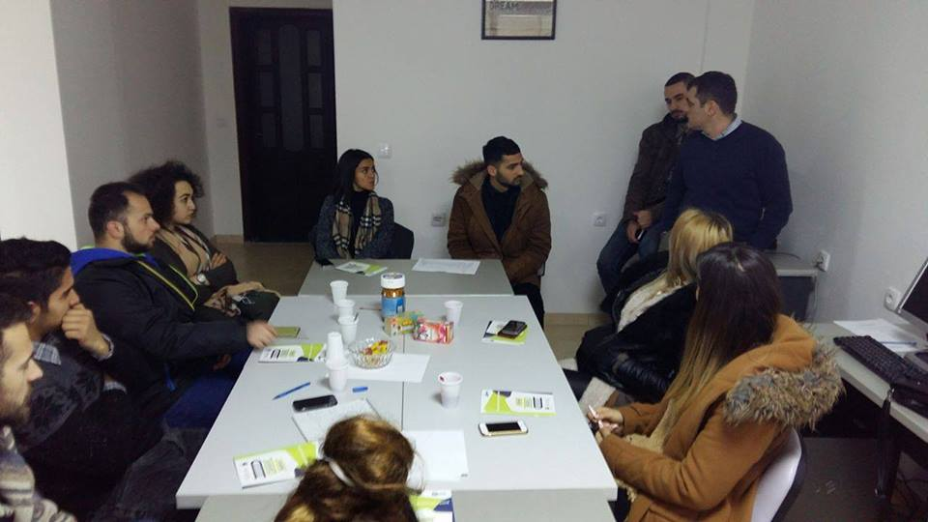

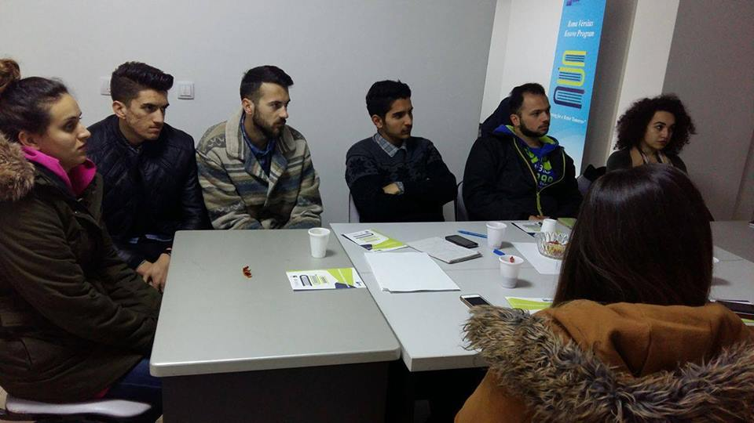

The RV Center Coordinators requested from the students to deliver their validated transcript of records after they have received results from exams at the university, in order to follow up the student’s progress in their studies.

Mentorship Services

During the reporting period, respective mentors organized 12 coordination and follow-up meetings with their students that were assigned to them. During the reporting period, RV has a total of 9 mentors through 3 RV student resource centers.
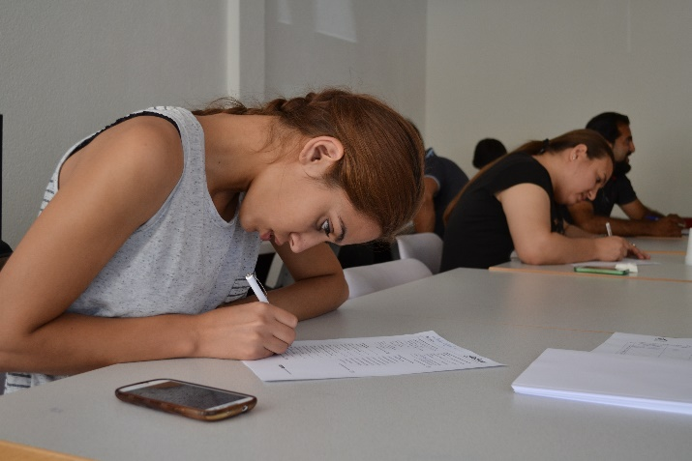
In line with their responsibilities, among other issues, they have delivered their monitoring reports as per instructions provided from RV Senior Program Officer and Program Manager. Mentors have organized les meetings with students in the period June – July 2016 because in this period were examination period and then summer holidays.

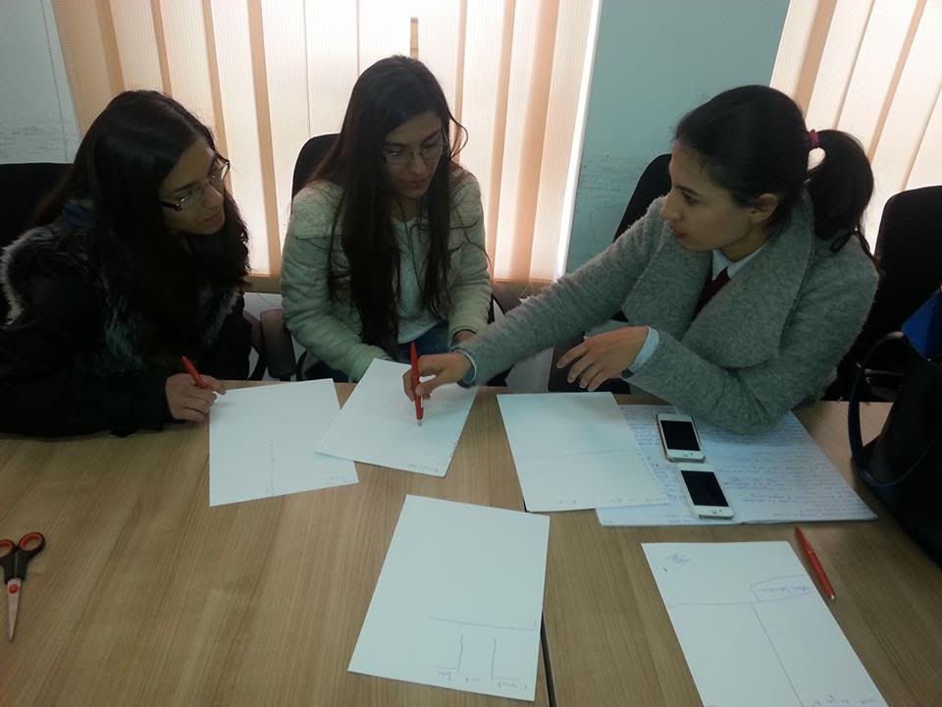

Foreign language

During the reporting period we have contacted several language tuition institutions and teachers in order to identify the best candidate for providing English and Romani language Courses for our student beneficiaries. Based on the above contacts, in course of summer holidays it is intended to implement this component of the RV program.
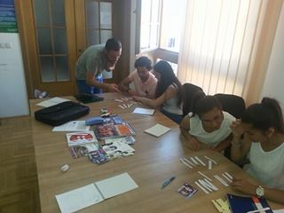
Based on the above contacts, we have selected teacher for English course in Prizren Mr. Edis Galushi RV alumni student who has finished Master Degree for English Language in Croatia. Mr. Galushi will work with 24 Students in Prizren Center. RV has requested from Mr. Galushi to deliver syllabus for English course that will last for 3 months. On 20th of June AT RV and the English teacher has conducted group selection test with RV students in order to identify their English language level. From the above test, two groups were created for English course: Elementary level and Pre-Intermediate level classes.
Below you can find pictures from group selection test held on 20th June 2016:
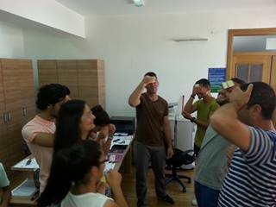
http://www.advancing-together.org/evente/
https://www.facebook.com/664694816926054/photos/pcb.1178975602164637/1178974272164770/?type=3&theater
https://www.facebook.com/664694816926054/photos/pcb.1178975602164637/1178974265498104/?type=3&theater
For RV Center in Peja and Prishtina we have selected Mr. Fahri Karaxhyzi English teacher with teaching experience more than 20 years and licensed for TOEFL tests. Mr. Karaxhyzi will organize English courses with students from Peja and Prishtina Center where will be more than 20 students in both centers.
On 25th of June AT RV and the English teacher Mr. Karaxhyzi has conducted group selection test with RV students from Peja center in order to identify their English language level. From the above test, two groups were created for English course: Elemen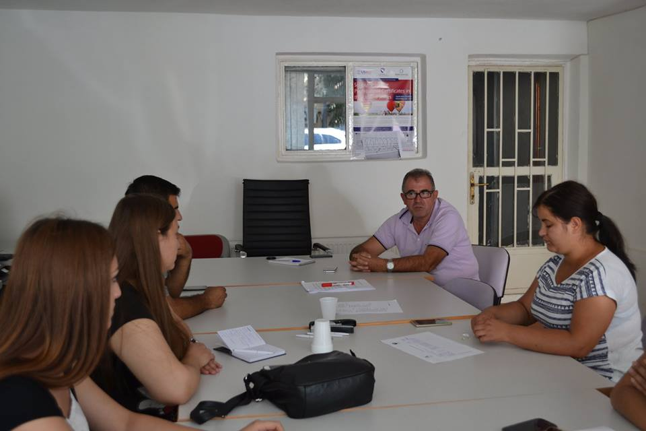tary level and Pre-Intermediate level classes.

Where test with students from Prishtina center were conducted beat later, on 12th of July 2016 where from test is created only elementary group.
Below you can find pictures from group selection test held on 12f July 2016:
http://www.advancing-together.org/
https://www.facebook.com/664694816926054/photos/pcb.1195348703860660/1195348330527364/?type=3&theater
https://www.facebook.com/664694816926054/photos/pcb.1195348703860660/1195348503860680/?type=3&theate

Roma language, Culture and History Course

During the reporting period we have contacted several certified trainers for Roma language, Culture and History, as we know in Kosovo it’s not easy to find certified and experienced teachers for Roma language, culture and history, after we have contacted several candidates we have decided to hire Mr. Avdi Misini certified trainer and experienced journalist from public national TV RTK.
Mr. Misini were requested to prepare syllabus for course, based on syllabus were organized course in Prizreni center with RV beneficiary students. The course stared on 9th July 2016 and ended on 2nd August 2016, at the end of training Roma Versitas Students received Certificate for training accomplishment.
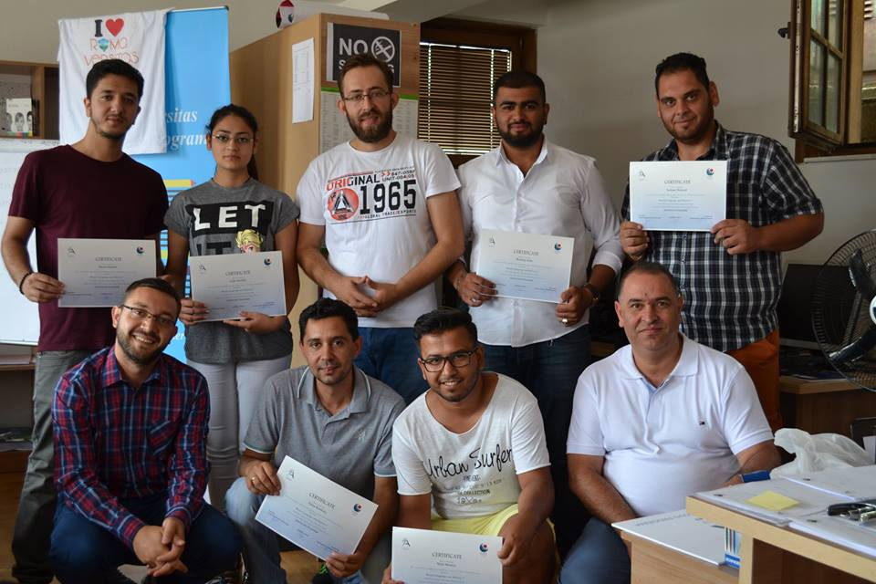

Below you can find pictures from Roma Language, Culture and History and certificate ceremony after successful competition of the course.
http://www.advancing-together.org/evente/
https://www.facebook.com/664694816926054/photos/pcb.1193224694073061/1193223550739842/?type=3&theater
https://www.facebook.com/664694816926054/photos/pcb.1193224694073061/1193223547406509/?type=3&theater

Computer courses

During the reporting period RV has contacted several companies and independent IT trainers in order to identify best price and trainer for providing Computer Courses for our student beneficiaries. Based on the above contacts, in course of summer holidays it is intended to implement this component of the RV program.

During the reporting period RV has contacted several companies and independent IT trainers in order to identify best price and trainer for providing Computer Courses for our student beneficiaries. Based on the above contacts, in course of summer holidays it is intended to implement this component of the RV program.
With the request of students computer courses were postponed for the period after the summer holidays.
Skills Trainings

During the reporting period we have contacted with Innovation Lab Kosovo for organizing two trainings, Project Proposal writing and Project Cycle Management training, we have agreed with Ms. Nita Zeqiri that ILK to provide trainer for trainings free of charge and RV will provide space where training will be held and other training material, food and refreshments for students.

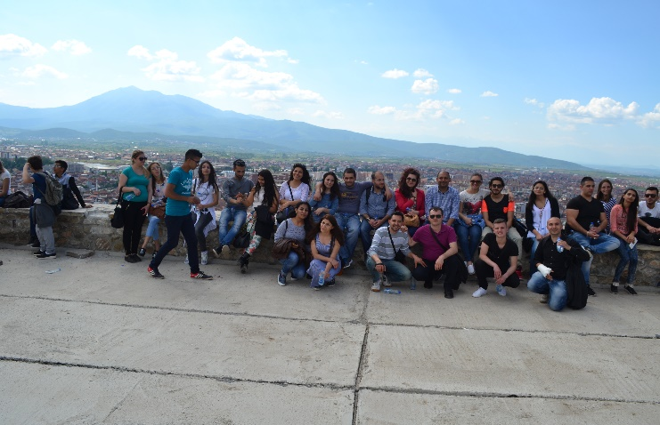
Initially, the training was planned to be held on 25th and 26th February 2016, due to lack of funds we were obliged to postpone for May or June 2016, RV could not implement trainings as per plan because the grant from REF has arrived on 08 April 2016.
During the reporting period, RV Kosovo with RV Albania has agreed to organize Academic Writing training with its beneficiary students in Kosovo, the training were planned to be held on 25th and 26th March 2016, the training were postponed for 22nd and 23rd of May 2016 for same reason as previous trainings lack of funds.
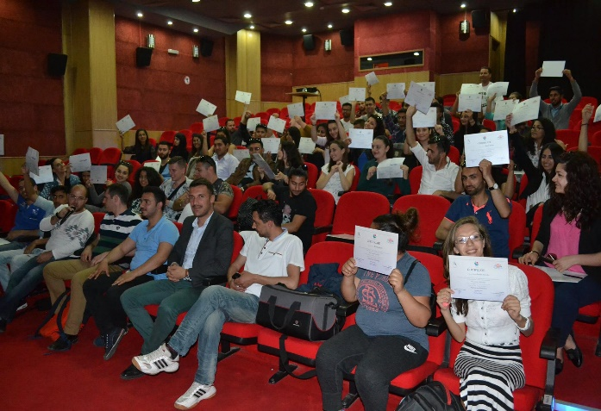

Provision of Academic Development Service

Upon agreement with AT and RV Albania, on 22nd and 23rd May 2016 the first cross-border cooperation activity was organized. Beside implementation of the formal learning activities (academic writing), the program had the opportunity to create space of inter-student socialization across countries and make them learn about each-other, combined with the fact of their own identity and formal way of gaining academic skills.
The purpose of these joint activities was to increase the capacity of students who are beneficiaries of these programs as well as socialization and knowledge of the traditions and culture and Roma identity in Prizren and Kosovo. Through this approach, the aim of this activity was to raise confidence among students, increase the level of inter- student knowledge in the field of academic subjects and socialization as a resource for student collaboration. This goal, furthermore achieved through exploration of Prizren as historical and cultural city where the students during the visit head chance to be informed closely with the culture and traditions of this city.
Hosting and accommodation of students from RV Albania was done by students of RV Kosovo, the students from Prizren hosted by three up to five students from Albania in their homes, this type of accommodation happened for first time, where Roma Versitas students hosted in their houses students from another country having the chance to know each other and learn for culture, traditions of Roma from Kosovo especially Roma from Prizren.

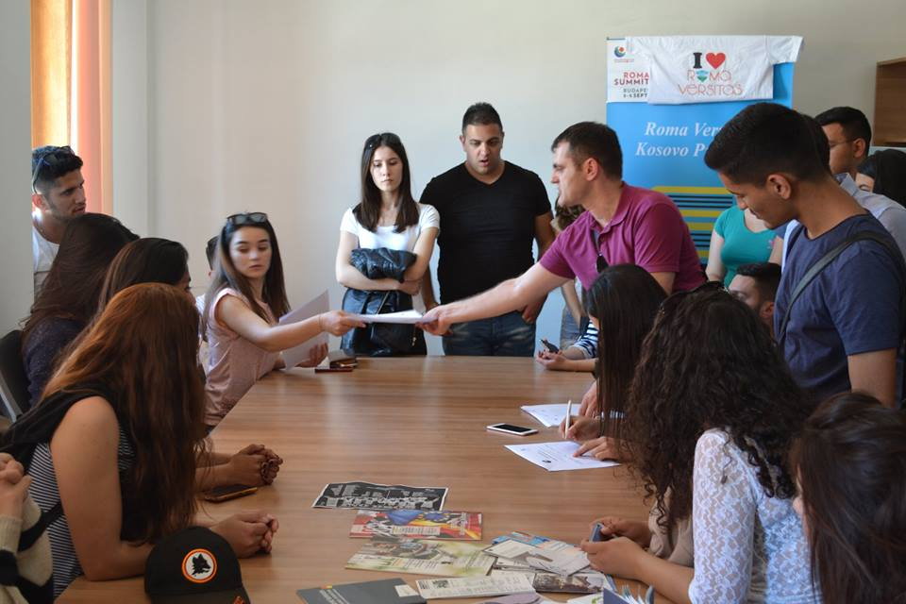

Social Activities
Hedenebir is a festival which is celebrated in Prizren Terzi Mahala neighborhood. This holiday has a connection with the celebrations of the day Shëngjergjit father Karabash shrine located in Prizren.
This celebration is called as small Shëngjergji and celebrated with 22 May in the neighborhood called Terzi Mahalla, and otherwise called as anthem day, according to the research made for this festival, is noted that shale was given to the Roma from Prizren, as a reward from the Ottomans to who they stayed in our lands before 500 years.
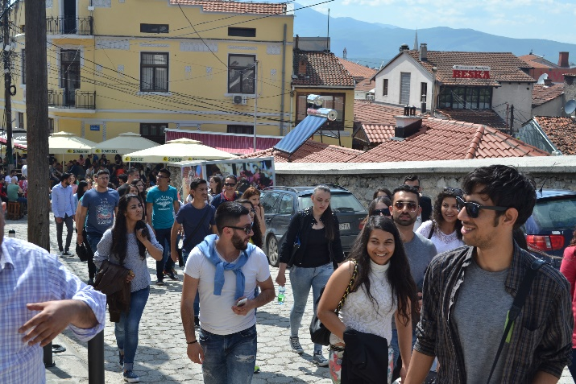

This award was given to Roma in Prizren, because this community has served Ottomans with their work of blacksmith by mrrethur swords soldiers were arranged by Kroc their shields (the metal breastplate) and so on.

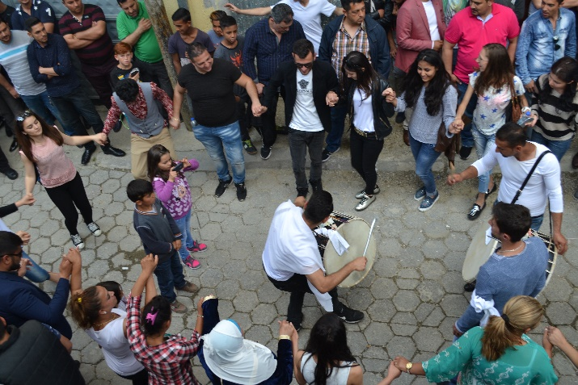

After their departure anthem is given as high reward to Roma community in Prizren and these symbol marks its traditional day on 22nd May of every year.
On 22nd May in Terzi mahala every house awaits guests from other neighborhoods of the city, also from other parts of Kosovo people come to attend this ceremony which is followed with drum, Surlet, Roma traditional dance from this neighborhood, where women, girls, old women dancing and so on.

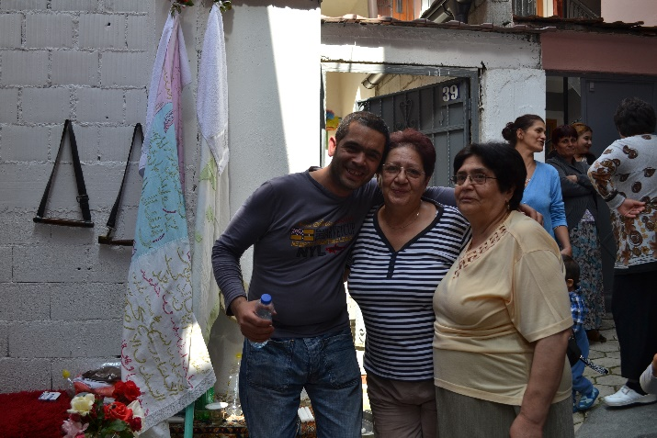

Anthem is accompanied by religious rites from members of faith Tarikat, singing different dua and ilahi, which arise in the center of the neighborhood and stay about an hour.
Most people visit anthem and pray for many things that they claim that this anthem which is written in Persian and Ottoman expect their desire to be filled for what they wish.

Then most of people whose desire is fulfilled scapegoat for sacrifice in the center of neighborhood and distribute the meat to the poorest people in the neighborhood and part of meat they prepare in their homes.
Throughout the night entire neighborhood awaits guest, during the night, people sung and prepare for the next day, and in the morning they visit the mausoleum Lez in a village which is located east of Prizren.
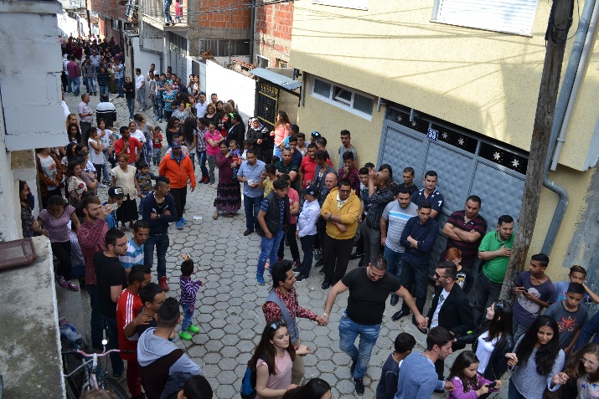
All citizens Kosovo wide organized one foot by cars they go to visit the mausoleum Lez in this village called Ymer Baba.
After staying in this mausoleum throughout the day in the hours after the day back in the neighborhood where shale continues still waiting bairak ceremony with drums and curl and so the ceremony ends and all the guests return to their homes.
In recent years this traditional festival has started to fade almost from the citizens who are religious, and say these beliefs are useless, and atmosphere is on certain days but not as a decade ago.

During this visit students were informed for the history of Hedenebir holidays and head chance to be part of this celebration and feel them self the celebration of the ceremony, below you can find link of pictures from the Hedenebiri ceremony:
http://www.advancing-together.org/evente/
https://www.facebook.com/1667376046851403/photos/pcb.1714847982104209/1714847402104267/?type=3&theater
https://www.facebook.com/1667376046851403/photos/pcb.1714847982104209/1714847402104267/?type=3&theater
https://www.facebook.com/664694816926054/photos/pcb.1159533024108895/1159527307442800/?type=3&theater
After The ceremony of Hedenerebir, students of RV Albania together with students from RV Kosovo went to visit castle of Prizreni (Fortress Kalaja e Prizrenit). It was built on a hill above Prizrenska Bistrica, around which the modern city developed. The first fort, erected on this location by the Byzantines, was further expanded by Emperor Stefan Dušan (r. 1331–55). The fort then came under the control of the Ottomans for four centuries. It was declared a Monument of Culture of Exceptional Importance in 1948.[1]
Below you can find pictures form castle visit from students:
https://www.facebook.com/1667376046851403/photos/pcb.1714847982104209/1714847398770934/?type=3&theater
https://www.facebook.com/664694816926054/photos/pcb.1159533024108895/1159526947442836/?type=3&theater
https://www.facebook.com/664694816926054/photos/pcb.1159533024108895/1159527214109476/?type=3&theater

Visit in the house of The League for the Defense of the Rights of the Albanian Nation (Albanian: Lidhja për mbrojtjen e të drejtave te kombit Shqiptar), commonly known as the League of Prizren, was an Albanian political organization founded on January 5, 1877. (Officially on June 10, 1878) in the old town of Prizren, in the Kosova Vilayet of the Ottoman Empire. Students head chance to visit this historical monument and learn about history of this League.

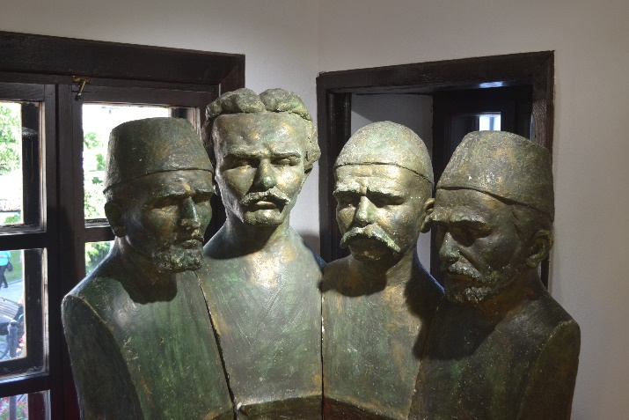

Below you can find pictures form the visit of Albanian League:
https://www.facebook.com/664694816926054/photos/pcb.1159533024108895/1159527640776100/?type=3&theater
https://www.facebook.com/664694816926054/photos/pcb.1159533024108895/1159527677442763/?type=3&theater
https://www.facebook.com/664694816926054/photos/pcb.1159533024108895/1159527780776086/?type=3&theater
https://www.facebook.com/664694816926054/photos/pcb.1159533024108895/1159527817442749/?type=3&theater
Marash visit:
https://www.facebook.com/664694816926054/photos/pcb.1159533024108895/1159527894109408/?type=3&theater

In the line of other activities developed there was also social activities developed with students of both RV’s with Mr. Driton Berisha one of successful RV Kosovo Alumni students. Mr Berisha organized series of ice breaking activities where students had opportunity to meet and to learn more about each other. By the end of the event there was organized a happy hour (party), where one the famous Roma Band (Jimmy Mustafa Band) performed, where he played a traditional and modern Roma music.

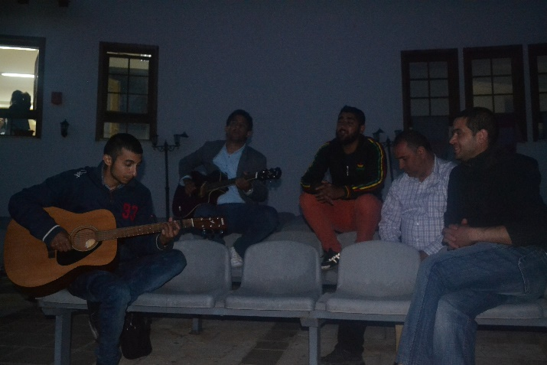

Academic Writing Workshop,
AT as host and organizer of the academic writing workshop, RV staff and Trainer developed training agenda for Academic Writing (essay writing; drafting, editing and reading of seminary work) and prepared needed materials for the training, invitation for the training were distributed via email, also were published in the AT website and through social networks, in the link below you can find training agenda.
http://www.advancing-together.org/wp-content/uploads/2016/01/Punetori-mbi-Shkrimin-Akademik-Final-Agenda-AT-RV-2016.pdf
On 23rd of May 2016 Roma Verstias Kosovo program staff has organized Workshop on Academic Writing. Participants from RV Albania and RV Kosovo who attend workshop were mainly Roma, Ashkali and Egyptian Students, also in this training were involved students from Albanian community. The workshop was held on Monday, starting from 10:00am, at DokuFest theater in RV Prizreni center building.
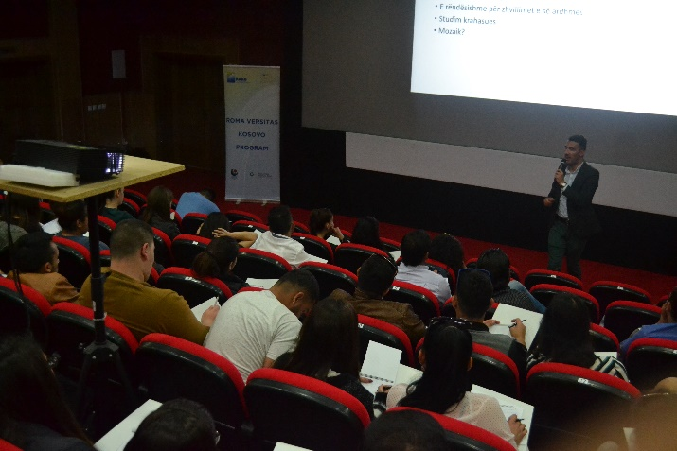
At the end of training Roma Versitas Students received Certificate for training accomplishment.
Below you can find pictures from the training:

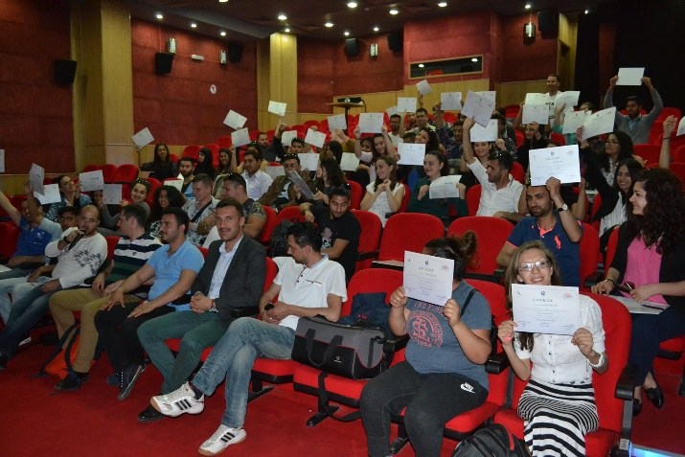

https://www.facebook.com/664694816926054/photos/pcb.1159911384071059/1159910990737765/?type=3&theater
https://www.facebook.com/664694816926054/photos/pcb.1159911384071059/1159910204071177/?type=3&theater
https://www.facebook.com/664694816926054/photos/pcb.1159911384071059/1159910674071130/?type=3&theater
Pictures from "Academic Writing" certificate ceremony and some great moments during interview for Prizren local TV BESA:

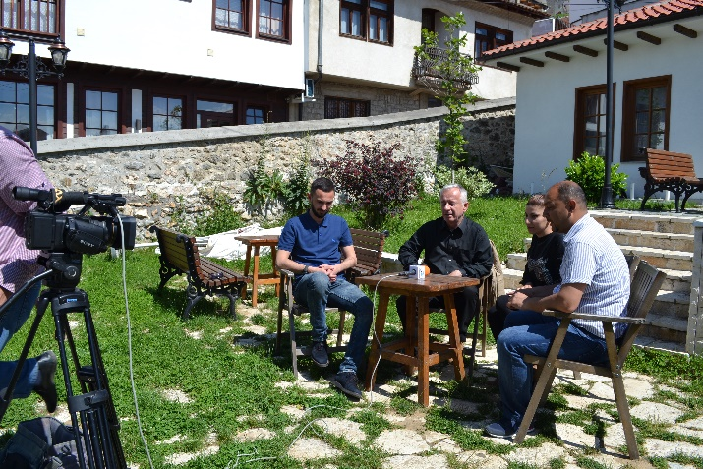

https://www.facebook.com/664694816926054/photos/pcb.1160193470709517/1160191840709680/?type=3&theater
https://www.facebook.com/664694816926054/photos/pcb.1160193470709517/1160192254042972/?type=3&theater
https://www.facebook.com/664694816926054/photos/pcb.1160193470709517/1160192817376249/?type=3&theater
https://www.facebook.com/664694816926054/photos/pcb.1160193470709517/1160192794042918/?type=3&theater
Documentary of the two days activities of RV Kosovo and RV Albania:
http://www.advancing-together.org/evente/
https://www.youtube.com/watch?v=-AY8CzqfbFo&feature=youtu.be
https://www.facebook.com/Advancing-Together-AT-1667376046851403/
https://www.facebook.com/Roma-Versitas-Kosovo-664694816926054/

Internship Program for Community Benefit

During this period RV Staff have developed ToR for interns, intern vacancy announcement was published in AT web site, social media RV Facebook page and sent via email to all RV students, for this call we have received three applications, selection process and interviews will be held in October 2016.

Other support provided to the students from RV Kosovo Program

On 15th April 2016 in RV center in Prizren, RV staff has facilitated information session with RV students for RMUSP application. The centers were used from students for online application where students have received assistance from RV.

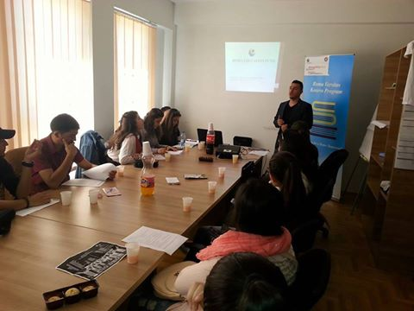

Below you can find link with pictures from RMUSP sessions with REF Country Facilitator in Prizreni RV Center:
https://www.facebook.com/664694816926054/photos/pcb.1136808566381341/1136805619714969/?type=3&theater
https://www.facebook.com/664694816926054/photos/pcb.1136808566381341/1136805629714968/?type=3&theater
Below you can find link with pictures from RMUSP sessions with REF Country Facilitator in Peja RV Center:

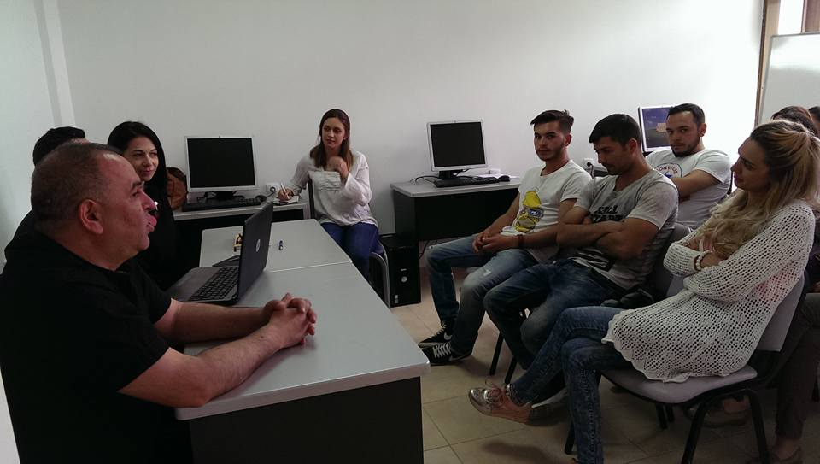

https://www.facebook.com/664694816926054/photos/pcb.1141384872590377/1141384312590433/?type=3&theater
https://www.facebook.com/664694816926054/photos/pcb.1141384872590377/1141384305923767/?type=3&theater

On 18th -19th April 2016, RV Kosovo Program hosted REF representatives Ms. Szilvia Pallagy, Mr. Peter Toth and Mr. Erxhan Galushi REF Country Facilitator for Kosovo for RV Kosovo program assessment. During the program assessment were organized three different meetings, first meeting were organized in Peja Center with REF representatives and RV Kosovo Tutors and Mentors where were discussed needs, progress and challenges of their work with students. Second meeting was organized with REF and RV students’ beneficiaries. REF representatives had the chance to meet with RV students and discuss their concerns and challenges related to their student career.
Third meeting were between REF and AT RV staff members from REF were present Ms. Szilvia Pallagy, Mr. Peter Toth and Mr. Erxhan Galushi and from RV Kosovo Program Mr. Bashkim Ibisishi Executive Director, Mr. Genc Broqi Program Manager, Mr. Avni Mustafa Senior Program Officer and Mr. Sami Canaj Admin&Finance Manager. In the meeting were discussed difficulties of students during their studies, activities implemented during the period September 2015 – March 2016, and activities in the plan to be developed in coming months.
Below you can find link with pictures from Meeting with REF, RV Students and Tutors/Mentors:

https://www.facebook.com/664694816926054/photos/pcb.1136766243052240/1136766109718920/?type=3&theater
https://www.facebook.com/664694816926054/photos/pcb.1136766243052240/1136766129718918/?type=3&theater
https://www.facebook.com/664694816926054/photos/pcb.1136766243052240/1136766176385580/?type=3&theater
https://www.facebook.com/664694816926054/photos/pcb.1136766243052240/1136766223052242/?type=3&theater

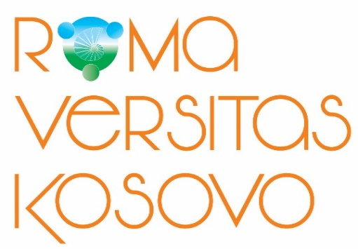

Contact US
ADVANCING TOGETHER
Roma Versitas Kosovo Program
Gazmend Zajmi No. 1, Pristhina, 10000 Kosovo
+381(0)38/248-008

Follow US
https://www.facebook.com/Roma-Versitas-Kosovo-664694816926054/
https://www.youtube.com/watch?v=-AY8CzqfbFo&spfreload=5

